Lab 07
Structured Assembly Programming
Objectives
- To understand the purpose and structure of the .data, .code, and .stack segments in organized assembly programs.
- To transition from flat assembly to structured programming for better readability, maintainability, and scalability.
- To write and execute simple structured programs in EMU8086 that demonstrate data declaration and character or string display.

Introduction
In the previous lab, programs were written in a flat assembly format, where all instructions were placed sequentially without separating data, code, or stack areas. This approach helped introduce the fundamental concepts of assembly such as registers, data movement (MOV instruction), and DOS interrupts (INT 21h) for performing basic input/output tasks.
While flat assembly is useful for learning the basics, it becomes difficult to manage as programs grow larger or more complex. To overcome this limitation, assembly language supports a structured programming model using segments.
In this lab, students will learn how to organize their code into three logical sections:
- .data segment – for declaring variables and constants.
- .stack segment – for allocating temporary storage space used during execution.
- .code segment – for writing executable instructions that operate on the data.
This structured approach mirrors how real assemblers like MASM handle larger programs and is essential for developing professional, maintainable assembly code. Students will apply this knowledge to write programs that display characters and strings using EMU8086 while adhering to structured coding conventions.
Program 1
.model small
.stack 100h

.data
char db 'A' ; Character to print

.code
main proc
mov ax, @data ; Initialize data segment
mov ds, ax

mov ah, 02h ; DOS print character function
mov dl, [char] ; Load the value from memory
int 21h ; Display it

mov ah, 4Ch ; Exit program
int 21h
main endp
end main
Explanation:
- model small, .stack 100h – Define memory model and stack space.
- data – Declare variable char holding 'A'.
- Initialize data segment with mov ax, @data and mov ds, ax.
- Set ah = 02h for DOS print function.
- Load character from memory into dl using mov dl, [char].
- Call int 21h to display the character.
- Use mov ah, 4Ch and int 21h to terminate the program.
- mov ax, @data: Loads the starting address of the data segment into the AX register.
- mov ds, ax: Copies the address from AX to DS to activate the data segment for correct data access.
Output:
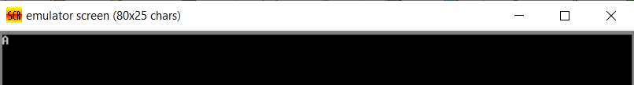

Relating to C++
int main() {
cout << "A";
return 0;
}
Assembly equivalent
main proc
mov ah, 02h
mov dl, 'A'
int 21h
main endp
end main

Memory Models
Memory Model | Code Segment | Data Segment | Description
TINY | One | One | Both code and data in a single 64KB segment (for .COM files)
SMALL | One | One | One code and one data segment (most common for .EXE programs)
MEDIUM | Many | One | Multiple code segments, one data segment
COMPACT | One | Many | One code segment, multiple data segments
LARGE / HUGE | Many | Many | Multiple code and data segments (for very large programs)

Printing string
.model small
.stack 100h

.data
msg db 'Hello, World!$' ; String ending with $

.code
main proc
mov ax, @data ; Initialize data segment
mov ds, ax

mov ah, 09h ; DOS print string function
lea dx, msg ; Load address of string
int 21h ; Display string

mov ah, 4Ch ; Exit program
int 21h
main endp
end main
Output
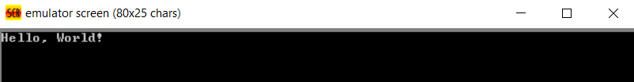
Explanation
- .model small, .stack 100h – Set memory model and stack.
- msg db 'Hello, World!$' – Define string (must end with $).
- mov ax, @data / mov ds, ax – Initialize data segment.
- mov ah, 09h – Select DOS function 9 (print string).
- lea dx, msg – Load address of string into DX.
- int 21h – Display string.
- mov ah, 4Ch / int 21h – Terminate program.

Difference between string and character
Purpose | Instruction | Why
Print a single character | mov dl, [char] | Because DOS function 02h expects the value of the character
Print a string | lea dx, msg | Because DOS function 09h expects the address of the string

Taking character input
.model small
.stack 100h

.data
msg db 'Enter a character: $'

.code
main proc
mov ax, @data
mov ds, ax

; Display message
mov ah, 09h
lea dx, msg
int 21h

; Take input
mov ah, 08h
int 21h ; Character stored in AL

; Display the same character
mov dl, al
mov ah, 02h
int 21h

mov ah, 4Ch
int 21h
main endp
end main
Output:
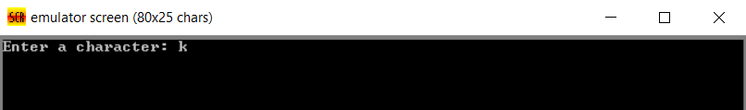

Explanation:
- Data Initialization: Sets up the data segment to access the msg variable.
- Display Message: Uses interrupt 21h with function 09h to print "Enter a character:".
- Input Character: Calls interrupt 21h with function 08h to take a single keystroke input (without echo).
- Store Input: The pressed key is stored automatically in register AL.
- Display Input: Moves AL to DL and prints the same character using interrupt 21h, function 02h.
- Program Exit: Ends the program gracefully using interrupt 21h, function 4Ch.
Adding two numbers
.model small
.stack 100h

.data
num1 db 5
num2 db 3

.code
main proc
mov ax, @data
mov ds, ax

mov al, num1 ; Load first number
add al, num2 ; Add second number (result in AL)

mov ah, 4Ch ; Exit program
int 21h
main endp
end main
Output
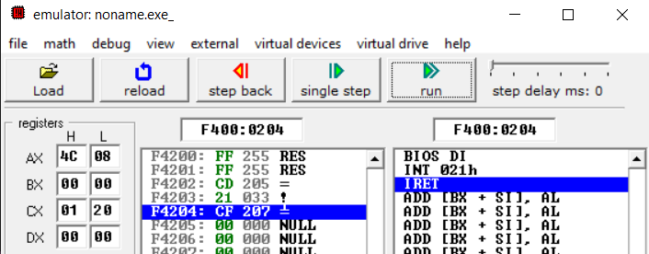
Arrays
.model small
.stack 100h

.data
arr db 10, 20, 30, 40, 50 ; Array of 5 bytes

.code
main proc
mov ax, @data
mov ds, ax

mov si, 0 ; Index = 0
mov al, arr[si] ; Load first element (10) into AL

mov si, 3
mov bl, arr[si] ; Load 4th element (40) into BL

mov ah, 4Ch ; Exit program
int 21h
main endp
end main

Output
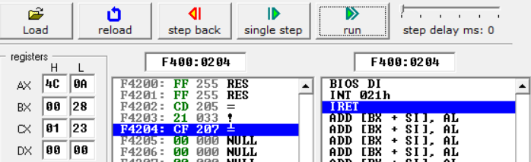
Offset not needed.
Case | Memory model | Why offset needed or not
MASM (.model small) | Segmented | DS already points to .data, so arr[si] automatically means DS:arr+si
Flat (NASM/FASM) | Flat | No segment setup — must explicitly use offset or lea to get addresses

Exercise:
Task 1: Take string input and display it on new line.
Task 2: Iterate over an array, calculate the sum and display with a message.
Task 3: Take two integer inputs and print the bigger number with a message.

